
COMPUTER AND INFORMATION TECHNOLOGY DEPARTMENT
Africa Nazarene University Gate Management System

BY
BRANDON NYAKEA
21S01ABT026
Supervisor - Ms. Jane Nteere
December 2025
Submitted in partial fulfillment of the requirements of the Bachelor of Business in Information Technology

Declaration
The Research Proposal presented in this report is my original work and has not been presented for any other University Award. Materials of work done by other researchers are mentioned by clear references.
Signature: __________________________ Date: _______________________________
Brandon Nyakea,
21s01abt026.

The Research Proposal has been submitted in partial fulfillment of the Requirements for the award of a Bachelor of Business Information Technology at Africa Nazarene University with my approval as the University supervisor.
Signature: __________________________________ Date: _____________________
Ms. Jane Nteere,
Lecturer,
Computer and Information Technology Department.

Dedication
Special thanks to my family and friends for their constant support, patience, and motivation.
Finally, I am thankful for the technical resources and tools made available, as they were essential in bringing this vision to life. Thank you all for making this project possible.

Acknowledgments
I would like to extend my deepest gratitude to everyone who supported and contributed to the successful completion of the "Automated Vehicle and Student Verification System" project.

First, my heartfelt thanks to my supervisor, Ms. Jane Nteere, whose invaluable guidance, feedback, and encouragement provided clarity and direction throughout the project journey.
I am also grateful to the ANU Security Department and gate personnel who shared their experiences, challenges, and aspirations for a more secure and efficient system. Their on-the-ground insights were instrumental in shaping the features and functionalities of this project to meet real-world needs.

Abstract
The "Automated Vehicle and Student Verification System" project aims to re-engineer the campus access control process at Africa Nazarene University (ANU) by addressing critical challenges of manual verification. The current system, which relies on manual checks of vehicles, student IDs, and personal assets like laptops, leads to significant delays, introduces security loopholes, and results in inefficient, error-prone record-keeping.
The proposed solution introduces a unified, automated platform for gate operators. This system will use Automatic Number Plate Recognition (ANPR) to instantly capture and verify vehicle license plates against a central registration database. Simultaneously, it will provide a mechanism for security personnel to verify a student's identity using their student ID and check the verification status of their laptop. The system is designed to support QR codes as a fast, mobile-first verification method and as an automatic fallback.
By consolidating these verification tasks into a single, efficient workflow, the system seeks to drastically reduce gate congestion and enhance security. The platform will automatically log all access decisions, detect and flag unauthorized entry attempts, and store all events in a secure database. This will provide administrators with the ability to generate exportable reports for security audits and analysis. By tackling the shortcomings of the manual-first approach, this project positions itself as a transformative tool to improve security, simplify access control, and enhance operational efficiency for the entire ANU community.

Table of Contents
Declaration ii
Dedication iii
Acknowledgments iv
Abstract v
Table of Contents vi
Chapter 1: Introduction 1
1.1. Background of the study 1
1.2. Problem Statement 2
1.3. Justification of the Problem 2
1.4. Goal 3
1.5. Objectives 3
1.6. Research Questions 4
1.7. Limitations of the Research 4
Chapter 2: Literature Review 6
2.1. Introduction 6
2.2. Local Review: Manual Security and its Challenges in Kenyan Universities 6
2.3. Regional Review: Siloed Automation in African Higher Education 7
2.4. International Review: The "Smart Campus" and Integrated Web Platforms 8
2.5. Conclusion 8
Chapter 3: Methodology 11
3.1. Introduction 11
3.2. Research Design/Approach 11
3.3. Research Methods 12
3.3.1. Requirements Gathering Methods 12
3.3.2. Design Techniques 12
3.3.3. Technologies and System Stack 13
3.3.4. Testing Methods 13
3.4. Timeline 14
3.5. Budget 15
3.6. Ethical Considerations 16
3.7. Conclusion 17
Chapter 4: System Design 18
4.1 Functional Requirements 18
4.1.1. Use Case Diagram 19
4.2 Non-functional requirements 19
4.3 Context Diagram 20
4.4 Data Flow Diagram (DFD) Level 0 21
4.5 Class Diagram 22
4.6 Entity Relationship Diagram 22
Chapter 5: System Prototype, Conclusion, and Recommendations 24
5.1. Introduction 24
5.2. System Prototype 24
5.3. System Description 27
5.4. User Interaction 27
1. Student / Staff Interaction 27
2. Guard Interaction 28
3. Administrator Interaction 31
5.5. Demonstration of Core Functionalities 33
5.6. Conclusion 35
5.7. Recommendations 35
References 36

List of Tables
Table 1 Comparative Analysis of Campus Access Control Paradigms 9
Table 2 Project Timeline 14
Table 3 Budget 15

List of Figures
Figure 1: Use Case Diagram 19
Figure 2: Context Diagram 20
Figure 3: Data Flow Diagram 21
Figure 4: Class Diagram 22
Figure 5: Entity Relationship Diagram 23
Figure 6: Asset registration form 27
Figure 7 : Student Dashboard with Asset listed 28
Figure 8: Guard action and options 29
Figure 9: Asset verification 30
Figure 10: Vehicle verification 30
Figure 11: Day scholar status 31
Figure 12: Administrator Dashboard (View Logs) 32

List of Abbreviations
ANPR - Automatic Number Plate Recognition
ANU - Africa Nazarene University
API - Application Programming Interface
CRUD - Create, Read, Update, Delete
DFD - Data Flow Diagram
ERD - Entity Relationship Diagram
PII - Personally Identifiable Information
PWA - Progressive Web App
QR Code - Quick Response Code
REST - Representational State Transfer
SQL - Structured Query Language
UAT - User Acceptance Testing
UI - User Interface
UX - User Experience

Chapter 1: Introduction

1.1. Background of the study

The landscape of campus security in higher education has been fundamentally transformed by the integration of digital technologies. Historically, university security relied almost exclusively on physical patrols and manual checkpoints at gates. This traditional model, while providing a human presence, is increasingly proving insufficient in the face of modern security challenges and the high-volume traffic of a modern university. The journey of technology in campus security began with closed-circuit television (CCTV) systems, which shifted security from a purely preventative to a reactive and investigative function. However, the advent of the "Smart Campus" concept, driven by the Internet of Things (IoT), cloud computing, and web platforms, has paved the way for proactive and automated security solutions (Appinventiv, 2025). These technologies are no longer supplemental but are becoming core components of an institution's safety infrastructure.
Key developments in this area include mobile-first credentials, such as QR (Quick Response) codes. These methods are faster, more secure, and more convenient than traditional physical ID cards, which can be easily lost, stolen, or forged (HID Global, 2025). Concurrently, digital logging systems have replaced paper ledgers, allowing for high-speed, contactless, and auditable data entry. While advanced systems like Automatic Number Plate Recognition (ANPR) exist, their cost and complexity can be prohibitive. A more accessible approach involves digital, manual-entry logs for vehicles, which still provides a significant improvement over paper-based systems by creating a searchable, digital record (Genetec, 2025).
Within the Kenyan context, the need for robust security is not merely a matter of convenience but of critical safety. Universities have been identified as "soft targets" and face persistent threats ranging from petty theft and unauthorized access to severe, large-scale security breaches (Githinji & Kanga, 2021). The tragic 2015 Garissa University attack underscored the devastating consequences of porous security and the critical need for systems that can accurately and efficiently verify every individual and vehicle entering a campus (Githinji & Kanga, 2021). This event served as a turning point, exposing the fatal vulnerabilities of relying solely on manual security protocols. Therefore, the shift from a manual, human-dependent security model to an integrated, data-driven one is a critical factor for ensuring safety and operational integrity in the contemporary higher education environment.

1.2. Problem Statement

The current reliance on manual and fragmented verification processes at the Africa Nazarene University (ANU) gates creates significant operational and security vulnerabilities. Security personnel must perform several disconnected tasks: manually checking physical student IDs, visually inspecting vehicle stickers against paper-based lists, and managing a physical logbook for day scholars signing in and out. This manual system suffers from fragmentation and inefficiency. It leads to long queues and delays for vehicles and pedestrians during peak hours, particularly at the Prof. Marangu Road gate, creating frustration for the university community.
More critically, it creates severe security loopholes. Manual verification is prone to human error, subjective judgment, and can be bypassed by forged documents. The physical sign-out book for day scholars is insecure, easily misplaced, and provides no real-time data on who is on campus, which is a significant risk during an emergency. Furthermore, the process results in unreliable and non-existent record-keeping, making it nearly impossible to conduct effective security audits, investigate incidents of theft, or analyze access patterns.
Existing literature covers standalone vehicle or student verification systems, but there is a clear gap in addressing the practical challenge of integrating these functions with other manual-but-critical tasks, like the day scholar log. The current system at ANU lacks a unified verification mechanism, streamlined digital workflows, and a central point of data capture, leading to congestion, security risks, and a suboptimal campus experience that hinders safety and operational efficiency.

1.3. Justification of the Problem

The problem of a manual, fragmented gate verification system is significant because it directly impacts the core mission of the university: to provide a safe and secure environment for learning. For students and staff, the daily delays create frustration and waste valuable time. The security loopholes create a tangible risk to personal safety and property. The high incidence of theft in university settings is exacerbated by a system that cannot effectively track valuable assets like laptops entering or leaving the campus. For day scholars, the manual book is an archaic and inefficient process.
For security administrators, the manual system provides no reliable data, making it difficult to analyze traffic patterns, allocate resources, or provide accurate reports after an incident. An integrated, digital system is therefore crucial to enhance operational efficiency, improve satisfaction among the university community, and most importantly, strengthen the university's security posture against both internal and external threats.

1.4. Goal

The primary goal of this project is to design, develop, and implement a prototype for an Integrated Gate Access and Asset Management System for Africa Nazarene University. This system aims to unify asset verification, vehicle logging, and day scholar management into a single, intuitive, and efficient web-based platform for gate security personnel, thereby enhancing campus security and operational efficiency.

1.5. Objectives

The specific objectives of this project are as follows:
- To develop a secure, student-facing web portal that enables students to securely register personal assets and vehicles by capturing unique serial numbers and license plates into a centralized database.
- To implement an automated QR code module that generates and assigns a unique, scannable digital credential for every registered asset immediately upon registration to facilitate contactless verification.
- To design an entry-point module that allows security personnel to scan student/staff ID cards for identity verification and includes a dedicated “Visitor Management” submodule to register and track external guests entering the university premises.
- To build a digital logging module that enables guards to manually input license plates for unregistered vehicles and automatically record entry/exit timestamps, distinguishing between registered members and visitors.
- To deploy a day scholar management module that enables guards to retrieve student records by ID and update their status (e.g., "Checked In" to "Checked Out") in real-time, replacing the physical logbook.
- To configure a management dashboard that generates comprehensive security reports by allowing administrators to filter gate logs by date range, guard ID, or event type (e.g., late entries or visitor logs) for audit purposes.

1.6. Research Questions

This study will be guided by the following research questions:
- What are the primary operational inefficiencies and security vulnerabilities in the current manual gate verification process at Africa Nazarene University?
- How can a unified system architecture be designed to effectively integrate QR-code-based asset verification, manual vehicle logging, and digital day scholar sign-outs into a single web platform?
- What are the core components required to build a self-service portal for asset registration and QR code generation using Django?
- How can a guard-facing web app be developed to perform the distinct tasks of QR scanning, manual data entry, and digital list management on a single interface?
- What database schema and backend logic are necessary to securely log all access events and provide administrators with a dashboard for generating meaningful security reports?
- What are the key findings and recommendations for a potential full-scale implementation of the automated verification system at ANU?

1.7. Limitations of the Research

This research and the resulting project are subject to the following limitations:
- Scope: The project will deliver a prototype with core functionalities. It will not be a full-scale, production-ready system. Advanced features such as integration with the university's central student information system, physical boom gate automation, or automatic license plate recognition (ANPR) are outside the scope of this prototype.The project will deliver a system with core functionalities. It will be a full-scale, production-ready system. Advanced features such as integration with the university's central student information system, physical boom gate automation, or automatic license plate recognition (ANPR) are outside the scope of this system.
- Offline Functionality: While the system will be designed as a Progressive Web App (PWA), the initial application's offline capabilities may be limited to basic caching. Full offline data synchronization (syncing logs created offline) is a complex feature that may be designated as future work.
- Research Methodology: The usability testing will be conducted with a small, convenient sample of security personnel from ANU. Therefore, the results may not be fully generalizable to the entire security department or other university staff.
- Generalizability: The findings and the proposed solution are tailored specifically to the context and needs of Africa Nazarene University and may not be directly applicable to other institutions with different technological infrastructures, security protocols, or administrative processes.

Chapter 2: Literature Review

2.1. Introduction

The adoption of digital solutions for campus security has become a cornerstone of modern university administration. Access control systems play a central role in protecting students, staff, and university property by regulating entry and exit at key points. This literature review provides a comparative analysis of local, regional, and international studies and systems related to campus access control technology. The objective is to situate the proposed "Integrated Gate Access and Asset Management System" within the broader context of educational and security technology. By examining how universities in Kenya, across Africa, and globally are leveraging technology for security, this review will explore established best practices, common pitfalls, and prevailing technological trends. The primary focus is on identifying critical gaps-specifically the lack of a unified, accessible system that combines digital vehicle logging, student, and asset verification-that can inform the design of an efficient system for ANU.

2.2. Local Review: Manual Security and its Challenges in Kenyan Universities

The security landscape of Kenya's higher education sector is defined by a unique and urgent set of challenges that render traditional security measures insufficient. The literature consistently highlights that universities are often perceived as "soft targets" and must contend with a wide spectrum of threats, including theft, burglary, unauthorized entry, and, in the most severe cases, terrorism (Githinji & Kanga, 2021). The 2015 terrorist attack on Garissa University, which resulted in 148 fatalities, stands as a stark and tragic testament to the catastrophic potential of security failures in this environment (Githinji & Kanga, 2021). This event is widely cited as a critical turning point that exposed the deep-seated vulnerabilities of manual, human-dependent security protocols.
In response, the prevailing strategy at most Kenyan universities, including major institutions like the University of Nairobi, involves "strict checking at the gate" by a 24/7 deployment of security personnel (University of Nairobi, 2024). This approach relies on guards manually inspecting physical student IDs, staff badges, and vehicle stickers. While this method provides a visible human deterrent, its effectiveness is severely limited. Research indicates that this manual paradigm is not scalable to handle high-traffic periods and is highly susceptible to circumvention through forged documents and simple human error. A study on academic credential verification in Kenya found that 80% of respondent universities had experienced cases of fake credentials, demonstrating a systemic weakness in manual verification that extends directly to gate access control (Ombui et al., 2023). This creates the precise loophole that allows for the persistent problem of unauthorized individuals "masquerading as students" to gain campus access. Furthermore, these manual systems and physical logbooks generate no reliable digital data, making it impossible to conduct meaningful security audits, analyze access patterns, or investigate incidents effectively.

2.3. Regional Review: Siloed Automation in African Higher Education

Across the African continent, higher education institutions are increasingly turning to technology to solve specific, isolated security challenges. The literature from the region shows a growing consensus that manual inspection processes are tedious, inefficient, and insecure, prompting the development of targeted automated solutions. However, a review of these efforts reveals a pattern of siloed implementation.
One significant trend is the development of Automatic Number Plate Recognition (ANPR) systems for vehicle management. Studies in South Africa demonstrate the use of ANPR for automating vehicle access and managing parking (Ademola & Mtonyi, 2020). These systems effectively use cameras and optical character recognition (OCR) to capture license plates and verify them against a database. However, these systems are often costly and complex to implement and maintain, and they are fundamentally "identity-agnostic." They can verify a vehicle but provide no information about the driver or their assets.
Concurrently, another distinct stream of innovation focuses on student identity verification, primarily through the use of Quick Response (QR) codes. A compelling case study from a polytechnic in Nigeria details the implementation of a QR code-based authentication system to manage student access to examination halls (Afolabi et al., 2023). The system, which involved students presenting a unique QR code for scanning, was highly successful in reducing verification time and student impersonation. This demonstrates that QR codes are a viable, effective, and accepted technology for secure student identification within an African higher education context. The clear and defining gap in the regional literature is the lack of integration. The solutions developed are effective but fragmented. A security guard at a university gate is tasked with verifying the vehicle, the student driver, and their registered assets in one interaction. The existing siloed approaches fail to address this real-world operational requirement.

2.4. International Review: The "Smart Campus" and Integrated Web Platforms

In developed markets, campus security has evolved into comprehensive, integrated digital ecosystems, often referred to as the "Smart Campus" paradigm (Appinventiv, 2025). The international best practice is characterized by unified, cloud-based, and mobile-first platforms that provide a seamless and data-rich security experience.
Leading international solutions offer unified security platforms that integrate multiple security functions—IP-based video surveillance, sophisticated access control, and ANPR—into a single, centralized dashboard (Genetec, 2025). Case studies from large public universities showcase how such integrated systems reduce operational costs and improve staff productivity by connecting access control with human resources and other enterprise systems (Inteconnex, 2024). A central pillar of the modern smart campus is the shift away from traditional physical ID cards towards mobile-first credentials, leveraging technologies like QR codes (HID Global, 2025).
While these comprehensive commercial platforms are powerful, their proprietary nature and high costs are prohibitive for many institutions. However, the technological principles they validate are now accessible through mature and powerful open-source technologies. The backend logic and secure APIs for a robust system can be built using frameworks like Django, a high-level Python web framework that encourages rapid development and clean, pragmatic design (Django Software Foundation, 2024). Django's built-in administrative interface is a particularly powerful feature, as it can automatically provide a secure, production-ready dashboard for security managers to manage users, assets, and reports, drastically reducing development time.
On the frontend, modern JavaScript libraries like React.js allow for the creation of fast, responsive, and app-like user interfaces (Meta Platforms, 2024). A React-based web app can easily access a device's camera for QR code scanning (using libraries like html5-qrcode) and provide a clean interface for the manual data entry required for vehicle logging. This combination of a Django backend and React frontend provides a direct, low-cost pathway to replicate the functional integration of expensive commercial systems, bridging the gap between international best practices and local implementation constraints.

2.5. Conclusion
The review of literature reveals a clear justification for the proposed project. The local Kenyan context establishes an urgent need to move away from insecure manual verification processes and physical logbooks. The regional landscape shows that while component technologies like QR codes are effective, they are implemented in silos and fail to address the holistic task of a gate operator. Finally, the international "Smart Campus" model provides a benchmark for integration, while modern, open-source web technologies like Django and React make this level of integration achievable at a low cost.
Based on this analysis, the key research gap is the lack of documented research on the design of a low-cost, unified access control system that integrates digital-manual vehicle logging, QR-code-based asset verification, and digital day-scholar management into a single, seamless workflow. The current project is designed to directly address this gap by synthesizing the proven effectiveness of individual web technologies into a cohesive, practical, and accessible solution for ANU.

Table 1 Comparative Analysis of Campus Access Control Paradigms
Paradigm (Example) | Primary Technology | Integration Level | Data & Auditing | Key Strength | Identified Shortcoming
Local (e.g., UoN) | Manual Checks, Physical Logbooks | None (Fragmented) | Paper-based or None | Human Presence/Deterrent | Highly Inefficient, Insecure, Prone to Forgery, No Data
Regional (e.g., Nigeria/SA Research) | ANPR or QR Codes | Siloed (Single-purpose) | Digital (but separate) | Solves one specific problem effectively | Lack of holistic verification (e.g., car without driver ID)
International (e.g., Smart Campus) | Integrated Platforms (ANPR, Mobile Credentials, CCTV) | Fully Unified | Centralized & Real-time | Comprehensive Situational Awareness | High Cost & Proprietary Technology
Proposed ANU System | React.js, Django, QR Codes, Manual Digital Log | Unified Workflow | Centralized & Digital | Addresses the holistic need with accessible web tech | Development complexity; not fully automated (ANPR)

Chapter 3: Methodology

3.1. Introduction

This chapter outlines the systematic methodology that will be employed to conduct the research and development for the "Integrated Gate Access and Asset Management System." The primary goal is to detail the plan for achieving the project's objectives in a structured manner. It describes the overall research design, the specific methods for gathering requirements, the techniques for system design, the choice of the development stack, and the strategy for testing. This methodology ensures that the project is technically feasible, user-centered, and aligned with modern software development best practices.

3.2. Research Design/Approach

The project will adopt an Agile development methodology. This model is characterized by breaking down the development process into small, manageable cycles or iterations. Each iteration involves planning, requirements analysis, design, coding, and testing, culminating in a functional piece of the overall system.
The choice of an Agile approach is justified by the nature of this project as a prototype developed within a dynamic academic environment. This methodology offers several key advantages over a more rigid, linear model like the Waterfall approach:
- Flexibility: An Agile design allows for requirements to be refined and adapted. This is crucial as feedback from security personnel may alter initial assumptions about the workflow (e.g., the best way to present the day scholar list).
- Rapid Prototyping: The project can focus on delivering the most critical feature first (e.g., the student registration portal), followed by the guard's scanning module. This allows for early and continuous testing.
- Stakeholder Engagement: Agile emphasizes continuous collaboration. This project will involve regular demonstrations with the supervisor and, where possible, security personnel, ensuring the final prototype is aligned with real-world operational needs.
- Risk Mitigation: By developing and testing in small increments, technical challenges (e.g., camera access from a web browser) can be identified and addressed early, reducing the risk of major setbacks.

3.3. Research Methods

This section details the specific methods and techniques that will be employed during the system development process, from initial data collection to final testing.

3.3.1. Requirements Gathering Methods

A mixed-methods approach will be used to gather a comprehensive set of system requirements.
- Primary Data Collection: Interviews will be conducted with security personnel at the ANU gates. The questions (see Appendix B) will focus on their current workflow, common challenges, pain points with the manual system (especially the day scholar book), and their expectations for an automated solution. The gate operations will be observed during peak and off-peak hours to understand traffic flow, average verification times, and common exceptions. The current physical day scholar logbook will be analyzed to understand the data fields it captures.
- Secondary Data Collection: This will involve the analysis of existing documentation, such as official university security protocols or guidelines, if available.
- Data Analysis: The qualitative data from interviews will be thematically analyzed to identify recurring needs and pain points. This analysis will directly inform the creation of user stories (e.g., "As a guard, I want to sign out a day scholar in two clicks so I can reduce the queue") and define the functional and non-functional requirements.

3.3.2. Design Techniques

The design phase will translate the gathered requirements into a technical blueprint.
System Architecture: A Client-Server Architecture will be designed.
- Server (Backend): A Django REST Framework API will handle business logic, user authentication (for students, guards, and admins), and database interactions.
- Client (Frontend): A React.js single-page application (SPA) will serve as the user interface. This will be a Progressive Web App (PWA) to ensure it is fast and installable on the guards' mobile devices.
- Database Design: An Entity-Relationship Diagram (ERD) will be created to model the database structure (see Chapter 4.6). This will define the entities (e.g., StudentProfile, Asset, Vehicle, GateLog) and the relationships between them.
- User Interface (UI) and User Experience (UX) Design: Wireframes and mockups of the student portal and the guard's dashboard will be created. The design will prioritize clarity, high contrast for outdoor readability, and large touch targets for ease of use on a tablet or phone.

3.3.3. Technologies and System Stack

The selection of technologies is based on the principles of using open-source, well-supported, and highly productive tools appropriate for rapid prototyping.
- Backend: Python with the Django framework: Django's "batteries-included" nature provides an Object-Relational Mapper (ORM) for easy database management, a robust security model, and a built-in admin panel that directly addresses Objective 5 (admin reporting) with minimal extra development (Django Software Foundation, 2024). Django REST Framework (DRF) will be used to build the secure APIs for the frontend.
- Frontend: JavaScript with the React.js library.
Why: React's component-based architecture is ideal for building a complex, interactive UI. Its large ecosystem includes libraries like html5-qrcode for accessing the device camera and scanning QR codes directly in the browser (Meta Platforms, 2024).
- Database: PostgreSQL.
Why: A powerful, open-source relational database that is robust, scalable, and works seamlessly with Django. SQLite will be used during initial development for its simplicity.
- Authentication: Simple JWT (JSON Web Token) for Django REST Framework will be used to secure the API and manage stateless authentication between the React frontend and Django backend.

3.3.4. Testing Methods

A multi-layered testing strategy will be employed to ensure the quality and reliability.
- Unit Testing: Individual components (e.g., the Django function to create a GateLog, the React component for the sign-out button) will be tested in isolation.
- Integration Testing: This will test the interactions between components, primarily focusing on the API. For example, ensuring the React frontend can successfully send data to the Django backend and that the data is correctly stored in the PostgreSQL database.
- System Testing: The entire end-to-end workflow will be tested (e.g., from a student registering an asset to a guard successfully scanning it).
- User Acceptance Testing (UAT): This is the most critical phase. The functional prototype will be demonstrated to a small group of ANU security personnel. They will be asked to perform predefined tasks (e.g., "Sign out student X," "Log entry for vehicle Y," "Verify this laptop"). Their interactions will be observed, and qualitative feedback will be collected to evaluate the system's usability and efficiency.

3.4. Timeline

The project will be completed over a 14-week period, following the phased approach detailed in the Gantt chart summary below:

Table 2 Project Timeline
Phase | Task | Week 1-3 | Week 4-5 | Week 6-8 | Week 9-11 | Week 12-13 | Week 14
1. Planning & Analysis | Requirements Gathering & Analysis | X
 | System Design (Architecture, ERD, UI) |  | X
2. Development | Backend Setup (Django, DB, API) |  |  | X
 | Student/Staff Portal (React) |  |  | X
 | Guard Web App (React) |  |  |  | X
3. Testing | Integration & System Testing |  |  |  |  | X
 | User Acceptance Testing (UAT) |  |  |  |  | X
4. Finalization | Final Report Writing & Revisions |  |  |  |  |  | X

3.5. Budget

The project is designed to be highly cost-effective by leveraging open-source software and existing hardware.
Table 3 Budget
Item | Description | Estimated Cost (KES) | Justification
Software | Python, Django, React, PostgreSQL, etc. | 0 | All key software components are open-source.
Hardware | Development & testing Computer | 0 | Using existing computer.
Hosting | Basic cloud server for prototype deployment | 1,500 | For deploying the web application for UAT and demonstration purposes.
Contingency | Miscellaneous (e.g., printing) | 500 | To cover unforeseen minor expenses.
Total |  | 2,000

3.6. Ethical Considerations

The development and implementation of this system necessitate careful consideration of ethical principles, particularly concerning data privacy and security.
- Data Privacy and Confidentiality: The system will handle Personally Identifiable Information (PII), including student names, ID numbers, vehicle license plates, and laptop serial numbers. The methodology will ensure all data is handled in accordance with data protection principles. The database will be secured, and access to the system will be strictly role-based.
- Informed Consent: All individuals participating in the research phase (interviews, UAT) will be fully informed about the project's purpose. Written informed consent will be obtained, ensuring they understand their participation is voluntary.
- Data Security: The system will be designed with robust security measures, including password hashing for all user accounts and secure JWT-based authentication for all API endpoints. Anonymized or synthetic data will be used for development and testing.

3.7. Conclusion

This chapter has detailed a comprehensive and structured methodology for the project. The selection of an Agile approach provides flexibility, while the mixed-methods requirements gathering ensures the system is grounded in user needs. The chosen technology stack (Python/Django and React.js) offers a modern, powerful, and feasible path for implementing the system's core functionalities. This methodology provides a clear roadmap for achieving the project's objectives and answering the guiding research questions.

Chapter 4: System Design

4.1 Functional Requirements
The system will be designed to perform the following functional requirements:
- User Management (Admin): The Administrator (Security Manager) shall be able to create, read, update, and delete accounts for Guards and Students via the Django Admin Panel.
- User Authentication: All users (Student, Guard, Admin) must log in with a secure, password-protected account.
- Asset Registration (Student): A logged-in Student shall be able to register their assets (e.g., laptop, tablet) by providing a serial number and model.
- Vehicle Registration (Student): A logged-in Student shall be able to register their vehicle(s) by providing a plate number, make, model, and color.
- QR Code Generation (System): The system shall automatically generate a unique QR code for each registered asset.
- Asset Verification (Guard): A logged-in Guard shall be able to scan an asset's QR code using a web app and instantly see the asset's details and the owner's name and photo.
- Vehicle Logging (Guard): A logged-in Guard shall be able to manually enter a vehicle's plate number. The system will search the database and display the registered owner's details or mark the vehicle as "Visitor." The guard will then log the entry or exit.
- Day Scholar Management (Guard): A logged-in Guard shall be able to view a list of all day scholars, mark them as "Signed Out" or "Signed In," and view a real-time list of who is currently on/off campus.
- Visitor Management (Guard): The system shall allow guards to record visitor names, National ID numbers, and the purpose of their visit.
- Reporting (Admin): The Administrator shall be able to view and filter all gate logs (vehicle, day scholar) by date, time, student, and guard, and export these logs.

4.1.1. Use Case Diagram
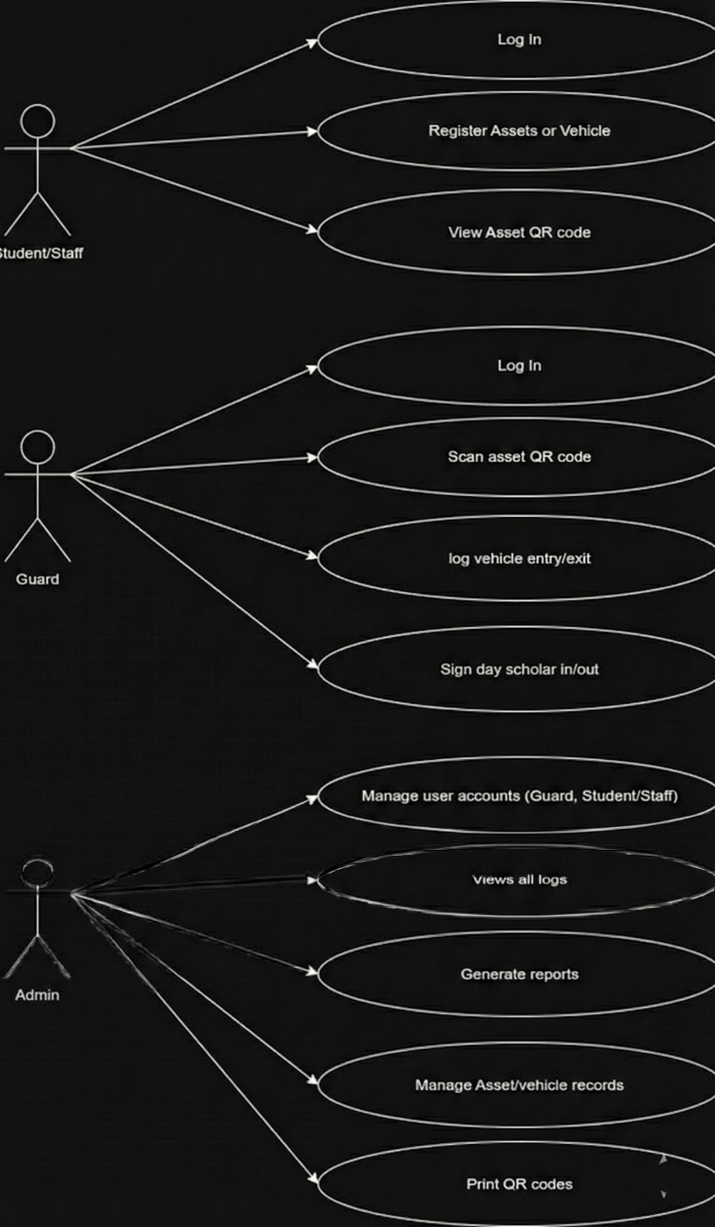
Figure 1: Use Case Diagram

4.2 Non-functional requirements
- Performance: All verifications (QR scan, plate lookup) must return a result in under 3 seconds.
- Usability: The guard's interface must be intuitive, with large touch targets and high contrast for outdoor visibility.
- Reliability: The system should have an uptime of 99.9%. All log entries must be transactional to prevent data loss.
- Security: All user passwords must be hashed. All communication between the frontend and backend must be over HTTPS and authenticated using JSON Web Tokens (JWT).
Maintainability: The code will be modular, well-commented, and use the standard Django and React project structures.

4.3 Context Diagram
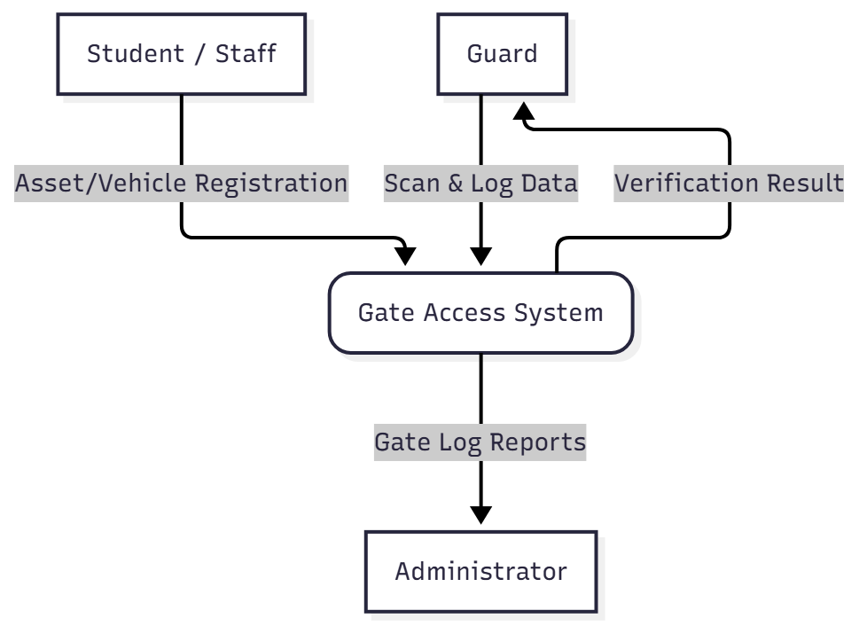
Figure 2: Context Diagram

4.4 Data Flow Diagram (DFD) Level 0
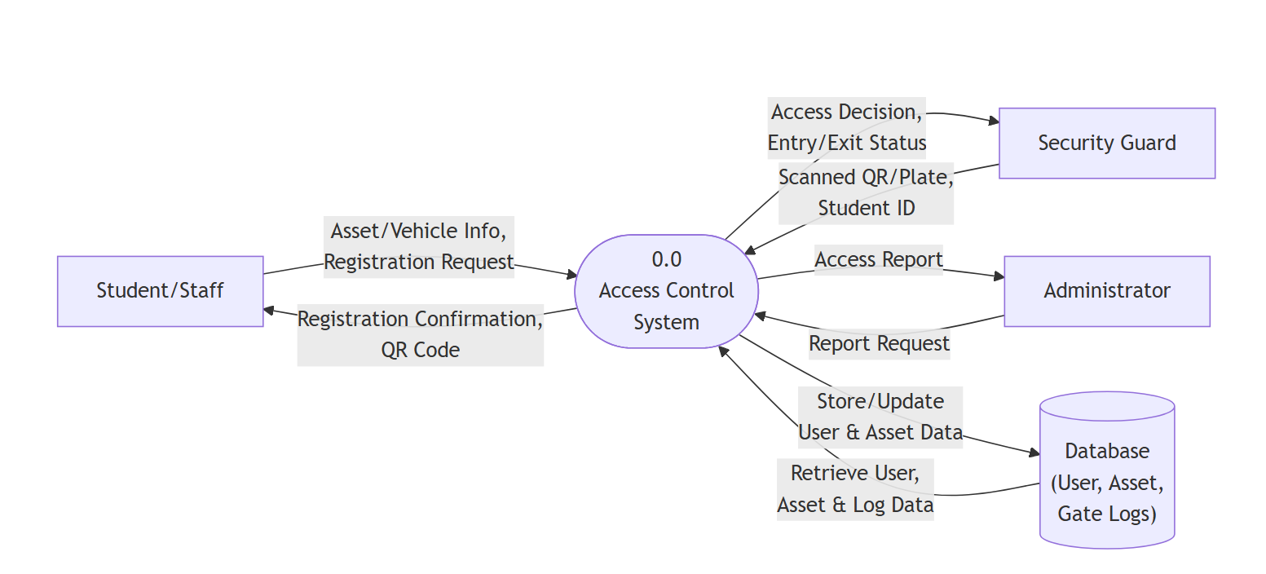
Figure 3: Data Flow Diagram

4.5 Class Diagram

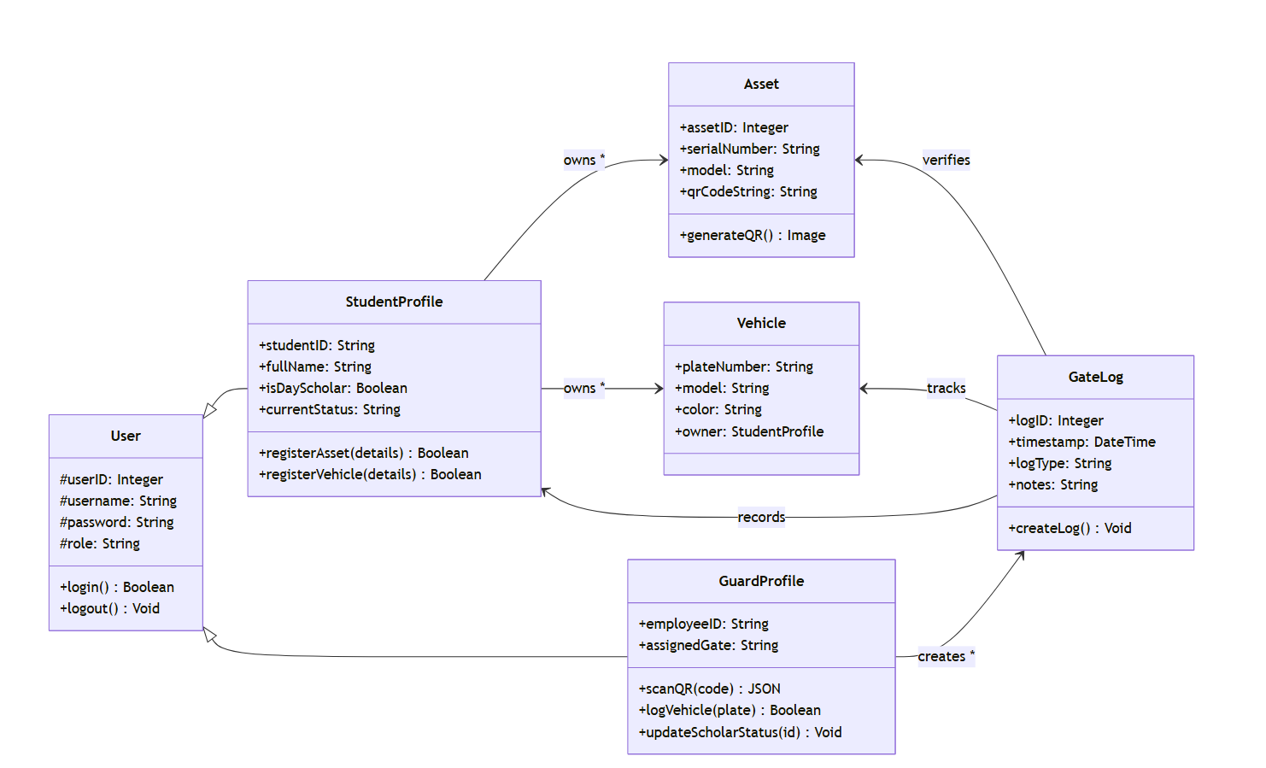
Figure 4: Class Diagram

4.6 Entity Relationship Diagram
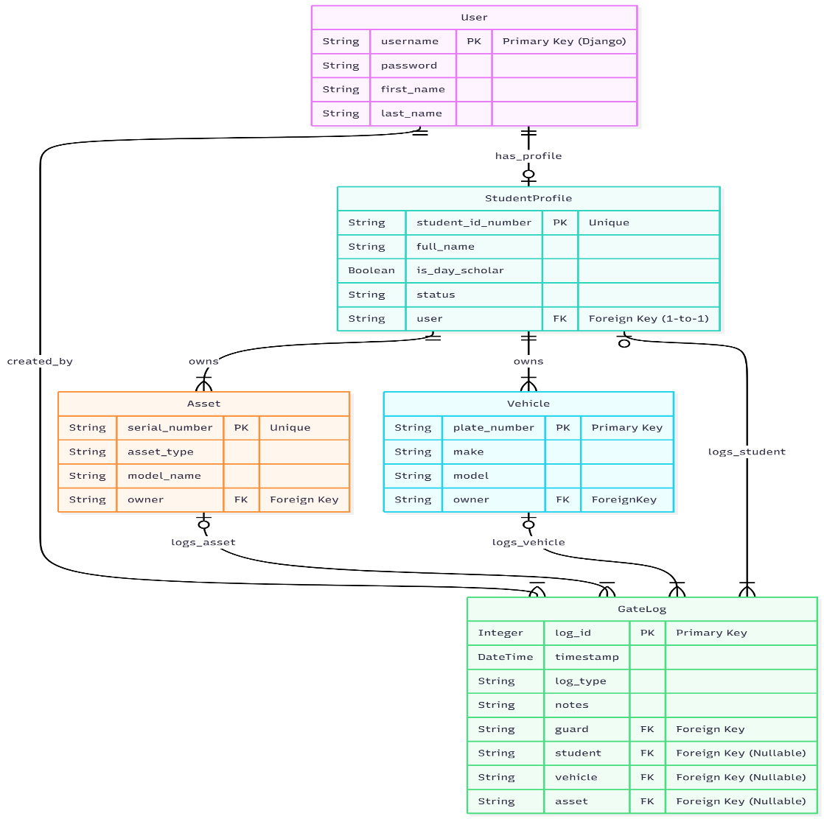
Figure 5: Entity Relationship Diagram

Chapter 5: System Prototype, Conclusion, and Recommendations

5.1. Introduction

This chapter will present the working prototype of the "Integrated Gate Access and Asset Management System." It will showcase the final functional system, explain how different users interact with it, and demonstrate how the prototype fulfills the project's core objectives. The chapter will conclude by summarizing the project's achievements, reflecting on challenges, and providing recommendations for future development and full-scale deployment at Africa Nazarene University.

5.2. System Prototype
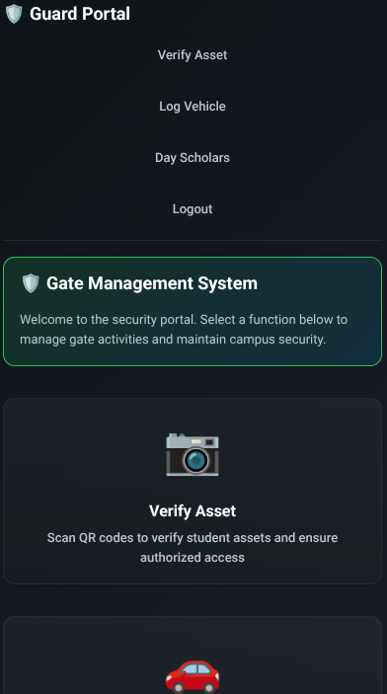
This is a login/signup screen This is the guard portal
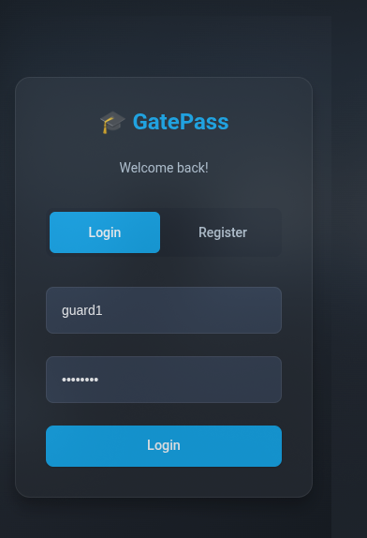

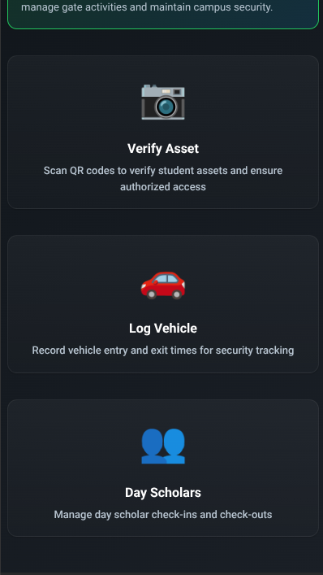
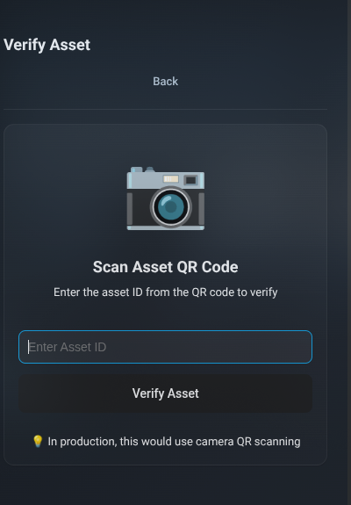

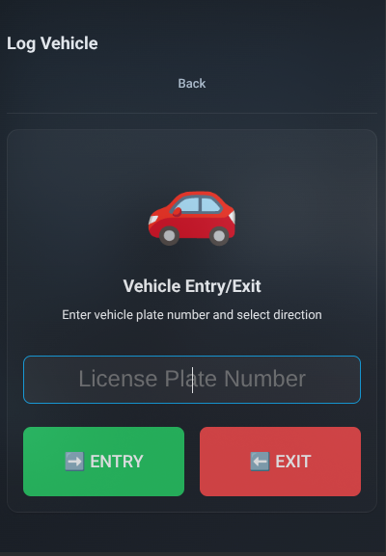
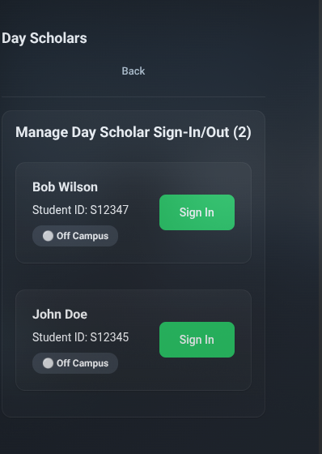
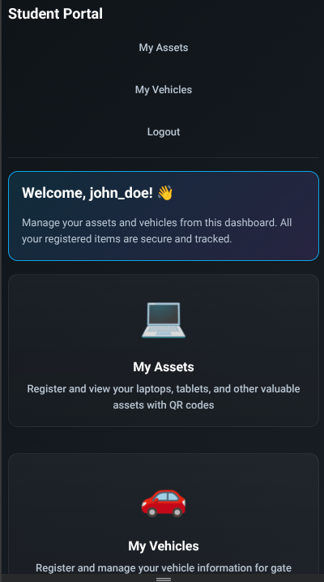

5.3. System Description

The final prototype will be a web-based application. The backend will be a Django REST Framework API, built with Python, handling all business logic and database operations. The database will be PostgreSQL. The frontend will be a responsive React.js Progressive Web App (PWA), ensuring it is fast, reliable, and installable on the guards' devices. The app will use the html5-qrcode library to access the device's camera for scanning.

5.4. User Interaction

The system is designed with three distinct user roles, each having a unique interface and set of permissions to perform their tasks.

1. Student / Staff Interaction
The student's primary interaction is through the self-service web portal, where they are responsible for pre-registering their personal items.
- Action: The student first logs in to the secure portal. They then navigate to the "My Assets" page and fill out a form to register their laptop, providing details like Asset Type and Serial Number.
- System: The system validates the data, links the new asset to the student's profile, and saves it to the database.
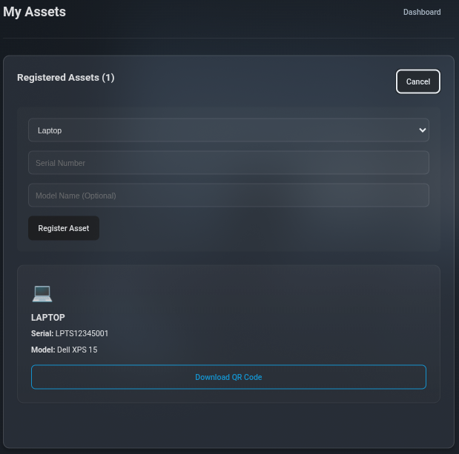
Figure 6: Asset registration form
A student can enter details of the asset they wish to register, and get it updated to the system
- Action: After registering an asset, the student naviges to the "My Assets" dashboard. They can now see a list of their registered items.
- System: The system displays each asset alongside a "View QR Code" button. Clicking this button reveals the unique, scannable QR code that the backend generated for that specific asset. The student can then print this code.
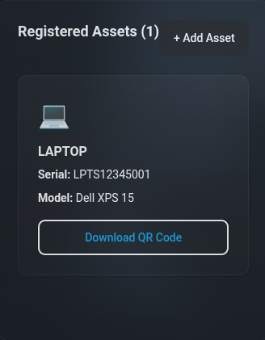
Figure 7: Student Dashboard with Asset listed

2. Guard Interaction
The guard interacts with the system via a mobile-first Progressive Web App (PWA) designed for speed and simplicity at the gate.
- Action: After logging in, the guard is presented with a main dashboard with three core functions. To verify an asset, the guard taps the "Verify Asset" button.
- System: The PWA activates the device's camera. The guard points the camera at the QR code on the student's laptop.

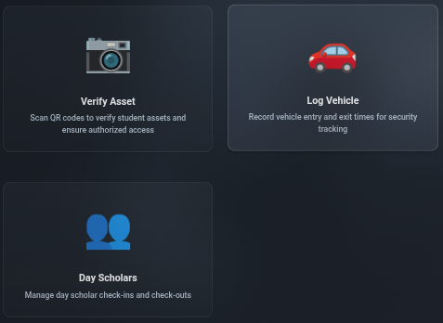
Figure 8: Guard action and options
The guard has three options; verification of assets, logging vehicles and signing day scholars in or out.

- Action: The guard scans the QR code.
- System: The app instantly queries the API. It then displays a clear, full-screen response: GREEN for a valid match (showing the asset and owner details) or RED for an invalid code.
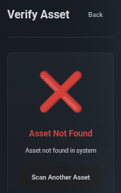
Figure 99: Asset verification
- Action: To log a vehicle, the guard taps "Log Vehicle." They type the license plate (e.g., "KDA 123X") into the input field and tap "Sign-In."
- System: The system searches the database for the plate. If found, it displays the registered owner's name. It then creates a new GateLog entry with the timestamp, guard's ID, and vehicle details.
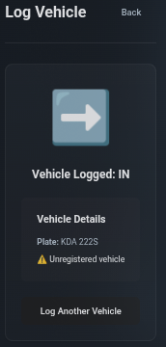
Figure 1010: Vehicle verification

- Action: To manage a day scholar, the guard taps "Day Scholars." They find the student's name in the list (or by searching) and tap the "SIGN-OUT" button.
- System: The system immediately updates the student's status to "OFF-CAMPUS," moving them to the "Signed-Out" list in real-time and creating a corresponding GateLog entry. This replaces the physical logbook.
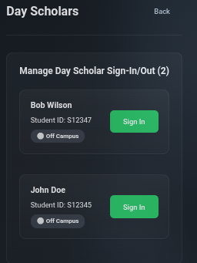
Figure 11: Day scholar status

3. Administrator Interaction
The administrator (e.g., a Security Manager) interacts with the system through the built-in Django Admin Panel, which serves as the secure administrative backend.
- Action: The administrator logs into the Django Admin Panel and navigates to the "Gate Logs" section.
- System: The system displays a complete, table-view of all gate events (vehicle entries, scholar sign-outs, etc.).
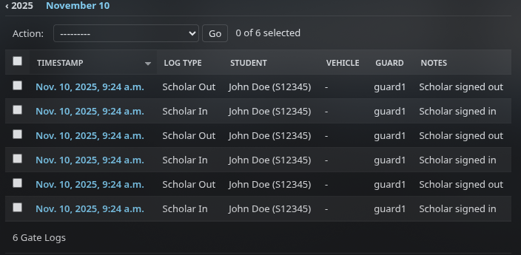
Figure 1212: Administrator Dashboard (View Logs)
The admin here is able to see all logs at the gates. The admin can see timestamps, guard doing the logs and who did what.

- Action: The administrator uses the built-in filters to generate a report. For example, they filter by Log Type = "Vehicle Entry" and by a specific Date Range.
- System: The admin panel filters the list to show only the requested vehicle entries. The administrator can then use an action (like "Export as CSV") to get their report.
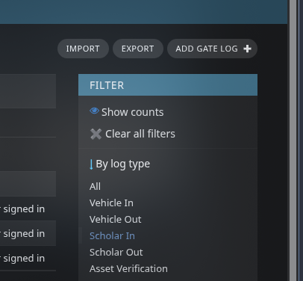
Figure 5.8: Administrator Generating a Filtered Report
The Administrator can apply custom filters and view logs. They can also export the selected log to their local system.

5.5. Demonstration of Core Functionalities
This prototype was developed to meet the six primary functional objectives outlined in Chapter One. The following section demonstrates how the system's core features successfully achieve each of those objectives.
- Objective 1: “To provide a student web portal that allows users to register their assets (e.g., laptops) and vehicles...”
Demonstration: The system provides a secure login for students, leading to a personal dashboard. From here, a student can navigate to the "My Assets" or "My Vehicles" page and fill out a simple form to register a new item. This data is validated by the Django backend and saved to the PostgreSQL database, successfully linking the item to the student's unique user ID.
- Objective 2: “To automatically generate a 100% unique, scannable QR code for each asset registered...”
Demonstration: Upon the successful registration of a new asset (e.g., a laptop), the backend generates a unique QR code. This QR code is immediately displayed on the student's "My Assets" dashboard next to the item. The student can then print this code or display it on their phone for the guard to scan.
- Objective 3: “To implement a guard-facing module that scans an asset's QR code... and displays a 'VALID' or 'INVALID' status.”
Demonstration: The guard's interface on their PWA (Progressive Web App) features a prominent "Scan Asset" button. This activates the device camera. When a QR code is scanned, the app sends the code to the API. The backend checks if the asset exists and belongs to the student. The app then displays a clear, full-screen response: GREEN for "VALID" (showing the student's name and asset details) or RED for "INVALID" (if the code is not in the system).
- Objective 4: “To provide a vehicle logging module where a guard can manually enter a plate number...”
Demonstration: The guard's interface has a "Log Vehicle" button. This opens a simple form with a large text field. The guard types in the license plate (e.g., "KDA 123X") and taps "Check-In" or "Check-Out." The system searches the database, finds the registered owner (if any), and creates a new, timestamped GateLog entry for that event in under 5 seconds.
- Objective 5: “To deliver a day scholar management module that allows a guard to... update their status... with a maximum of two clicks.”
Demonstration: The "Day Scholars" tab on the guard's PWA displays a real-time list of all day scholars currently "ON-CAMPUS." When a student wishes to leave, the guard finds their name (or searches by ID) and taps the "SIGN-OUT" button next to their name. The student's status is instantly updated, and they are moved to the "OFF-CAMPUS" list, creating a digital log of the exit. This entire process replaces the manual paper logbook.
- Objective 6: “To configure the administrative dashboard to allow an admin to generate gate log reports...”
Demonstration: The built-in Django Admin Panel serves as the administrative dashboard. An administrator can log in and view the GateLog table. This view provides powerful, built-in filters. The admin can successfully filter all gate logs by date range, guard on duty, and log type (e.g., "Vehicle Entry," "DayScholar-Out") to see a complete history of all gate activities.

GitHub Link = https://github.com/brandonthis-that/GatePass.git

5.6. Conclusion

This section will summarize the project's achievements. It will restate the problem of fragmented, manual gate systems at ANU and explain how the developed prototype provides a direct, unified, and data-driven solution. It will comment on the extent to which the objectives were met and reflect on the primary challenges faced during development (e.g., ensuring QR scanning is fast in various lighting conditions) and how they were overcome.

5.7. Recommendations

This section will provide practical suggestions for the future of the system.
- Offline Capability: Fully develop the PWA's offline synchronization. The app should be able to log all gate activities while offline and automatically sync with the central database once a connection is re-established.
- Integration with University SIS: Integrate the system with the main university Student Information System (SIS) to automatically pull student profiles, eliminating the need for manual account creation.
- ANPR Integration: As a future upgrade, explore integrating a low-cost ANPR solution. The system is designed to accommodate this; a vehicle log could be triggered automatically by a camera instead of manually by a guard.
Physical Barrier Automation: The system's API could be used to trigger physical boom barriers, further automating the entry/exit process for approved vehicles.

References

Ademola, J., & Mtonyi, J. (2020). A review of automatic number plate recognition systems for vehicle access control in South African universities. Journal of Information Systems Engineering & Management, 5(3), 1-12.
Afolabi, A., Oteze, P., & Ojo, S. (2023). Development of a QR code-based authentication system for managing student access to examination halls. International Journal of Computer Science and Information Security, 21(4), 88-95.
Appinventiv. (2025). How smart campuses are redefining the future of education. Retrieved November 7, 2025, from https://appinventiv.com/blog/smart-campus-technology-for-higher-education/
Django Software Foundation. (2024). About Django. Retrieved November 7, 2025, from https://www.google.com/search?q=https://www.djangoproject.com/about/
Genetec. (2025). Unified security for education. Retrieved November 7, 2025, from https://www.genetec.com/solutions/industries/education
Githinji, S., & Kanga, A. (2021). Effect of emergency preparedness on security in Kenyan universities: A case study of Garissa University. International Journal of Development and Management Review, 16(1), 45-58.
HID Global. (2025). Access & identity security solutions for universities. Retrieved November 7, 2025, from https://www.hidglobal.com/industries/universities
Inteconnex. (2024). University campus security system | Case Study. Retrieved November 7, 2025, from https://inteconnex.com/portfolio/university-campus-security-system/
Meta Platforms, Inc. (2024). React – A JavaScript library for building user interfaces. Retrieved November 7, 2025, from https://react.dev/
Ombui, V., Okeyo, G., & Mwangi, E. (2023). Multifactor authentication requirements for academic credential verification in Kenyan universities. International Journal of Research in Engineering and Science, 11(7), 134-142.
University of Nairobi. (2024). Security and safety services. Retrieved November 7, 2025, from https://mombasa.uonbi.ac.ke/basic-page/security-and-safety-services

